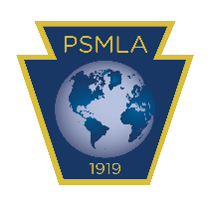


PSMLA Global Scholars Program

High School Application

Complete all categories appropriate for your school. (Not all categories may apply.) |  |  | Date
School Name |  |  | Phone no.
Address
City, State |  | Zip code
Superintendent |  | Email address
Principal |  | Email address
Supervisor of World Languages |  | Email address
Department Chair |  | Email address
Global Scholars Advisor |  | Email address
Faculty who are PSMLA members
(At minimum, the Global Scholars Advisor MUST be a PSMLA member.)
 |  | Email address
 |  | Email address
 |  | Email address
 |  | Email address
 |  | Email address
 |  | Email address
 |  | Email address
 |  | Email address
 |  | Email address
 |  | Email address
World Languages offered in the high school |  | Levels of each language (ex: I, II, II H, III, III H, AP, etc.)
Courses currently in the school’s curriculum that are primarily (50% or more) global in nature
- Social Studies:
- Business:
- English/Literature:
- Science:
- Math:
- Art:
- Music:
- Theater:
- Other:

Please send as an email attachment to Rochele Reitlinger: rochele@psmla.org

